Researchers Discover Huge Underground Water Reserves In Africa
By Meera Dolasia on April 26, 2012
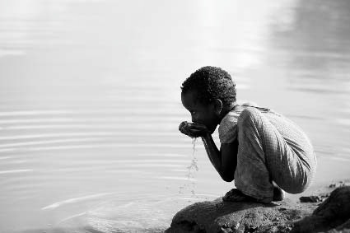
While fresh water reserves are declining in many parts of the world, nowhere is the situation as dire as the continent of Africa where, over 300 million people have no access to safe drinking water and only 5% of the arable land is being irrigated.
Now, there is finally some good news - Researchers from the British Geological Survey and University of College London recently revealed the discovery of a large source of underground water, which hopefully will provide a buffer for the continent, during severe drought years.
According to the research team, while the 0.66 million cubic kilometers of underground reserves are spread across the continent, a bulk of them are located in aquifers under some of the Africa's most arid countries - Libya, Algeria, Egypt, Chad and Sudan. While that may not sound like a lot of water, it is 100 times more than that currently found on the ground.
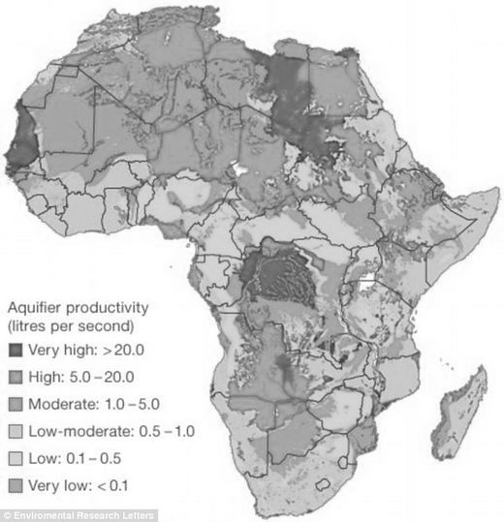
The researchers who put together this data by gleaning over maps based on hundreds of government geological and aquifer studies, believe that most of the water accumulated about five thousand years ago, when the region was much wetter.
While this is tremendously encouraging news, there are many hurdles to accessing this water. First and foremost, there is the issue of distance - A lot of the underground reserves are about seventy-five meters deep, and therefore, impossible to extract by digging small boreholes and drawing it up with the help of hand pumps. While large commercial drilling projects could do the job, it is expensive and experts worry that they could rapidly deplete all the water, leaving the continent in an even worse situation, given that they would never get replenished.
Also, there is the question of the quality of the water - The researchers have no idea if the water is contaminated or possibly even salty. Having said that, some of the water is on higher ground and could provide a lifeline for some communities when things get really bad, since it can be drawn up using affordable hand pumps.
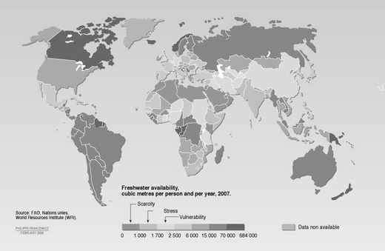
Experts from the United Nations Environmental Program are therefore urging African countries not to even attempt to access this newly found reserves but instead, focus on improving the ground water supply by creating better collection and storage tools. According their spokesperson, Nick Nutalli, there is currently a lot of water available, but it is rarely collected. Hopefully, things will change in the near future.

- Define the following terms in your own words
Dire:

Buffer:

Arid:

Replenish:

Gleaning:

- What did researchers find that could help solve the water shortage in Africa?
__________________________________________________________________________________________________________________________________________________________________________________

- Describe the problems with extracting the water from the underground reserves.
__________________________________________________________________________________________________________________________________________________________________________________
__________________________________________________________________________________________________________________________________________________________________________________

- Based on the information given in the article, do you agree with the United Nations Environmental Program that the newly discovered water should be left alone? Why or why not??
__________________________________________________________________________________________________________________________________________________________________________________
__________________________________________________________________________________________________________________________________________________________________________________
__________________________________________________________________________________________________________________________________________________________________________________

