South African Naturalist Shares Home With Exotic Cats
By Meera Dolasia on July 26, 2009
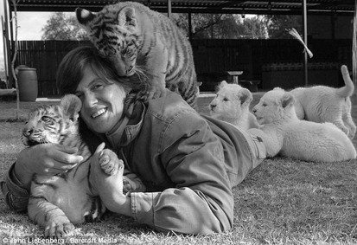
Riana Van Nieuwenhuizen is so worried that wild cats will become extinct if we don't do something to save them, that she has adopted not one, but eleven of them. Her menagerie of pets includes four cheetahs, five lions and two tigers.
Even more astonishing is the fact that the entire crew and her two dogs, all live harmoniously in her big sprawling home. While that would not be particularly surprising if these animals spent their days roaming in some big outdoor area, what is stunning is that all eleven reside inside her house in Free State, South Africa.
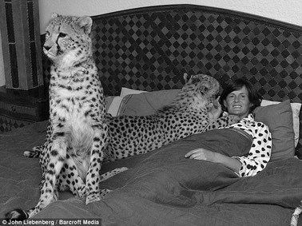
Riana's association with the animals began in 2006, when she bought an 8-week old abandoned cheetah cub, Fiela and started to hand-raise her. She enjoyed the experience so much that in 2007, she launched the Fiela Funds Cheetah Breeding Project, a non-profit foundation to ensure the survival of these exotic rare cats.
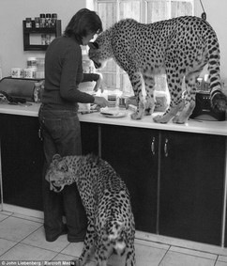
Slowly, she started to add the other pets to her collection. Most of them came to her as babies who had either been abandoned or injured. Hand-raised and trained, they move in and out of her house with extreme familiarity.
To give you an idea of how domesticated they are - they play with Riana's dogs instead of chomping them down for dinner. They are however very vocal when hungry, and let it be known by jumping up on the kitchen counter.
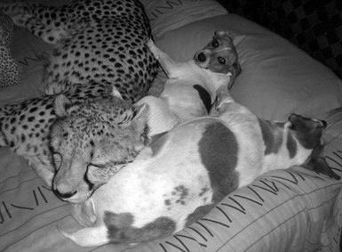
Besides accepting donations for her foundation, Riana also allows tourists in for a small fee. Visitors are able to get up close and personal with these gorgeous animals and she even has a wedding package for those special pictures.
In addition to the exotic cats, she also has animals like giraffe, springbuck and warthogs. However, those are not allowed into the house - Only the really dangerous ones have that privilege! To read more about Riana's eleven pets, go to cheetahexperience.com.

- Define the following terms in your own words.
Menagerie:

Astonishing:

Harmoniously:

Domesticated:

- Why has Riana taken wild cats into her home?
__________________________________________________________________________________________________________________________________________________________________________________

- Provide two examples of textual evidence to support how all the animals live harmoniously in Riana’s homes.
__________________________________________________________________________________________________________________________________________________________________________________
__________________________________________________________________________________________________________________________________________________________________________________

- OPINION (must be supported though!)
After reading this text and touring the Carolina Tiger Rescue, discuss your opinion on if you believe that people should take in wild cats (or other animals) as pets. Provide at least three examples to support your opinion!
__________________________________________________________________________________________________________________________________________________________________________________
__________________________________________________________________________________________________________________________________________________________________________________
____________________________________________________________________________________________________________________________________________________________________________________________________________________________________________________________________________________________________________________________________________________________________

