Use evidence in the sentences and context clues to write definitions for the bold words. You may use other resources if necessary.

Ancient Africa

Today, (1)deforestation in the central African rainforests is a serious issue as rainforests are destroyed in order to harvest timber, mine mineral resources, and make room for increased agriculture.

West African Empires relied on the (2)Gold-Salt Trade wherein (3)caravans would transfer salt from the East across the Sahara in exchange for the gold from western mines.

West African peoples relied on oral traditions to transmit beliefs and history through stories and folktales told by storytellers known as (4)griots.

As the leader of Mali, (5)Mansa Musa converted to Islam and created a western center of learning and conversion centered around Timbuktu.

Caravan leaders sometimes kept the location of an (6)oasis secret in order to gain an advantage over other Saharan traders.

The (7)Sahara Desert is the largest in the world and is slowly spreading southward through a process called desertification.

Much of Africa is covered in vast grasslands known as the (8)Savannah where many of Africa's most famous large animals live.

Many African societies relied on (9)subsistence farming, unable to produce more food than what was needed just to survive.

Ancient East African City-States like Zanzibar used (10)Monsoon winds to sail across the Indian Ocean and traded with peoples as far away as India and South Asia.

(11)Proverbs, short sayings containing wisdom that is accepted as truth, are used in many African cultures to offer advice, warnings and solutions to problems.

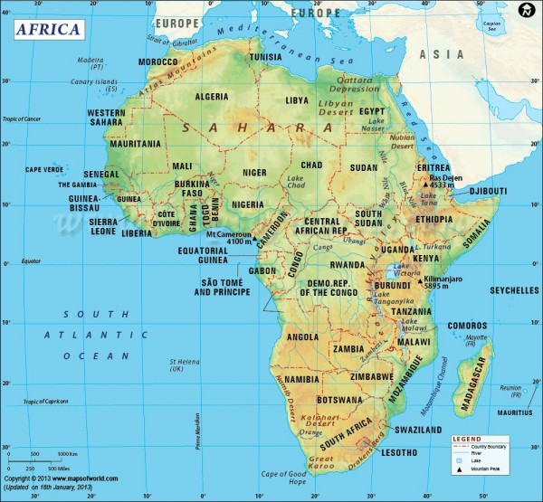
http://voices.nationalgeographic.com/2013/10/31/getting-to-know-africa-50-facts/
- African continent is the world’s oldest populated area.
- Arabic is spoken by 170 million people on the continent.
- Over 25% all languages are spoken only in Africa with over 2,000 recognised languages spoken on the continent.
- Africa is the second most populous continent with about 1.1 billion people or 16% of the world’s population.
- There are fewer people with Internet connections in Africa than there are in just New York City.
- There are 54 countries and one “non-self governing territory”, the Western Sahara, in Africa.
- Africa is the world’s second largest continent covering about over 30 million square kilometers
- The Sahara is the largest desert in the world and is bigger than the continental USA.
- Africa is the world’s hottest continent with deserts and drylands covering 60% of land surface area
- Lake Victoria is the largest lake in Africa and the second-largest freshwater lake in the world.
- The Nile River is the longest river in the world with a total length of 6,650 kilometers.
- Africa has eight of the 11 major biomes and the largest-remaining populations of lion, elephant, rhinoceros, cheetah, hyena, leopard and hundreds of other species.
- Water scarcity impacts the lives of over 300 million Africans, of whom approximately 75% of Africans rely on groundwater as their primary source of drinking water.

