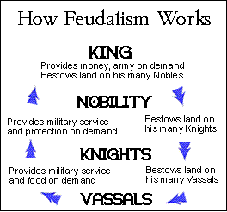
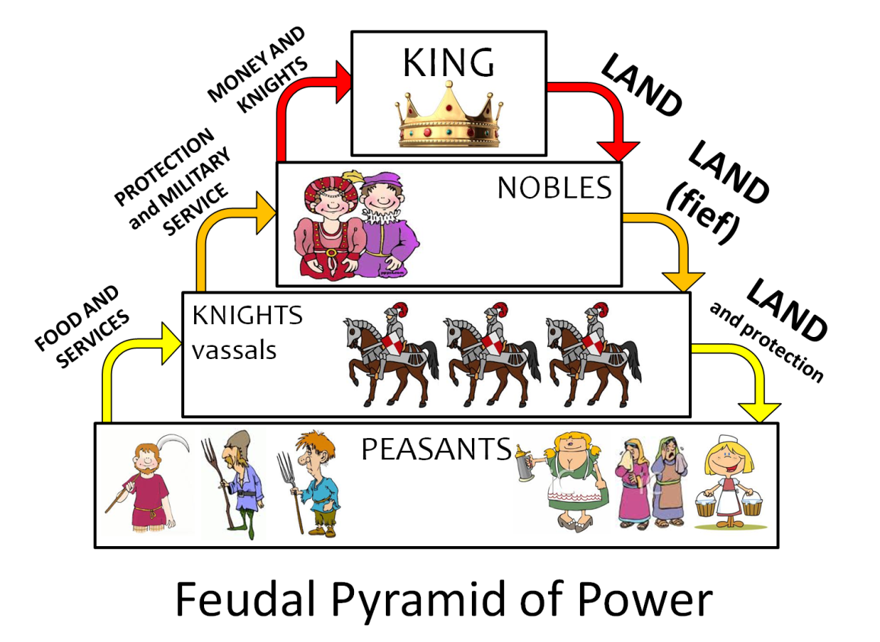
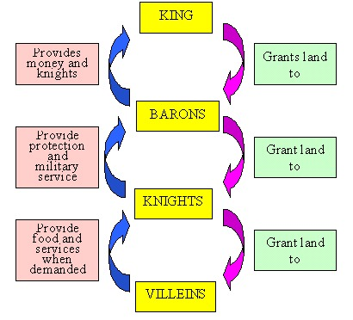
D
C
B
A
Directions – Examine the four diagrams AND watch the video on Discovery Education to understand Feudalism and answer the following questions.

1. List three things that all diagrams have in common.
1.
2.
3.

2. List two significant differences between the diagrams.
1.
2.

3. Use the information in the diagrams to define feudalism in your own words.

6. If you could only look at one diagram of feudalism, which of the four would be most useful? A B C D

Why?

7. If you could only look at one diagram of feudalism, which of the four would be least useful? A B C D

Why?

https://app.discoveryeducation.com/player/view/assetGuid/F4F6CE07-362B-4C48-BF8D-60625F16A97E

0-0:50
8. How did the people of lower social classes show respect to the upper classes?

1:00-1:40
9. What would a Lord be rewarding with if he went to battle for the king? Explain!

1:50-3:00
10. According to the video, what are the roles of the serfs? What were their restrictions?

2:45-3:10
11. What ruled the serfs’ lives? (Not the king)

3:10-5:08
12. Describe the roles and lifestyles of knights.

13. What was training for knighthood like?

